AI RECRUITER – SHORTLIST A SUITABLE CANDIDATE FOR A SPECIFIC JOB ROLE
A MAJOR PROJECT REPORT Submitted to
JAWAHARLAL NEHRU TECHNOLOGICAL UNIVERSITY, HYDERABAD
In partial fulfillment of the requirements for the award of the degree of

BACHELOR OF TECHNOLOGY
In
COMPUTER SCIENCE AND ENGINEERING
BY
V. KAVYA (18UK1A05M6)
N. SPANDANA (18UK1A05G2)
T. VISHNU PRIYA (18UK1A05H5)
B. AISHWARYA (18UK1A05J2)
Under the esteemed guidance of
Ms. T. SUSHMA
Assistant Professor

DEPARTMENT OF COMPUTER SCIENCE AND ENGINEERING
VAAGDEVI ENGINEERING COLLEGE
Affiliated to JNTU, HYDERABAD
BOLLIKUNTA, WARANGAL-506005.
DEPARTMENT OF COMPUTER SCIENCE AND ENGINEERING
VAAGDEVI ENGINEERING COLLEGE
Affiliated to JNTU, HYDERABAD
BOLLIKUNTA, WARANGAL-506005.
2018-2022

CERTIFICATE

This is to certify that the Major Project Report entitled “AI RECRUITER-SHORTLIST A SUITABLE CANDIDATE FOR SPECIFIC JOB ROLE” is being submitted by V.KAVYA (18UK1A05M6), N.SPANDANA (18UK1A05G2), T.VISHNU PRIYA (18UK1A05H5), B.AISHWARYA (18UK1A05J2) in partial fulfillment of the requirements for the award of the Degree in Bachelor of Technology in computer science and engineering during the academic year 2018-2022.

Ms. T. SUSHMA Dr. R. NAVEEN KUMAR
Project Guide Head of The Department

EXTERNAL EXAMINER
ACKNOWLEDGEMENT
We wish to take this opportunity to express our sincere gratitude and a deep sense of respect to our beloved Dr. P. Prasad Rao, Principal, Vaagdevi Engineering College for making us available all the required assistance and for his support and inspiration to carry out this major project in the institute.
We extend our heartfelt thanks to Dr. R. Naveen Kumar, Head of the Department of CSE, Vaagdevi Engineering College for providing us with the necessary infrastructure and thereby giving us the freedom to carry out the major project.
We express heartfelt thanks to the Mini Project Coordinator, Ms. G. Aruna kranthi, Assistant Professor, Department of CSE for her constant support and giving necessary guidance for the completion of this major project.
We express heartfelt thanks to the guide, Ms. T. SUSHMA, Assistant Professor, Department of CSE for her constant support and for giving necessary guidance for the completion of this major project.
We express our sincere thanks and gratitude to The Smart Bridge, for providing an internship.
Finally, we express our sincere thanks and gratitude to our family members, friends for their encouragement and outpouring their knowledge and experience throughout the thesis.

ABSTRACT
This project aims at building software that can screen the applicant's resume and send an email alert regarding their candidature.
Resume screening is the most time-consuming part of the recruiting process for high-volume agencies and internal recruiters. Stats from LinkedIn shows that recruiters spend an average of 23 hours on screening resumes for a single hire, but AI resume screening can help reduce this time.
Considering that the average job opening receives at least 250 resumes, of which 75% can be unqualified, it’s no surprise that talent acquisition leaders report the hardest part of recruitment is screening candidates from large applicant pools. Using recruiting automation or AI resume screening is a potential solution to this problem.
Technical Architecture:
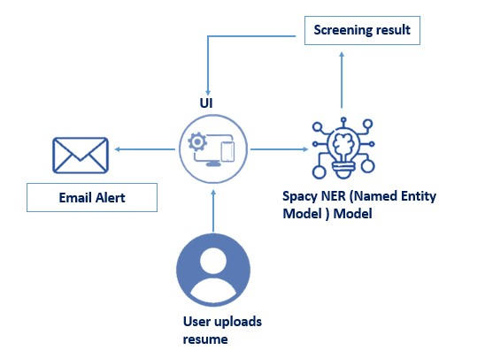

Pre requisites:
To complete this project, you must require the following software’s, concepts, and packages
Anaconda navigator
- Spyder Ide
- python packages
- Concepts regarding Named Entity Recognition

Anaconda
Anaconda/ PyCharm IDE is Ideal to complete this project
To install Anaconda, please refer to Anaconda Installation Steps
To install PyCharm IDE, please refer to PyCharm IDEInstallation steps
Anaconda Reference : https://www.youtube.com/watch?v=5mDYijMfSzs

Python Packages
Install the Following Packages:
- resume parser-A simple resume parser used for extracting information from resumes
- spacy- Library for Natural Language Processing in Python. It features NER, POS tagging, dependency parsing, word vectors and more.
- flask -Web application framework for building UI
- smtp- This library is for connecting to Gmail account To install the above packages go to open anaconda prompt and type
- "pip install flask" and click enter
- "pip install spacy" and click enter
- "pip install pyresparser" and click enter
- "pip install secure-smtplib" and click enter
Resume parser Reference : https://pypi.org/project/pyresparser/
Spacy Reference : https://pypi.org/project/spacy/

Prior Knowledge
You should know the below concepts:
- Python
- Flask basics
- Named Entity Recognition
Flask Basics : https://www.youtube.com/watch?v=lj4I_CvBnt0
Named Entity Recognition Reference :
https://medium.com/mysuperai/what-is-named-entity-recognition-ner-and-how-can-i-use-it-2b68 cf6f545d

Project Flow
The projects flow:
- The user interacts with the web app to apply for the desired job
- Uploads his resume
- Skills in the resume get screened
- An email about his candidate is triggered based on matched skills

Project Structure
Your Project Folder Should lie look below
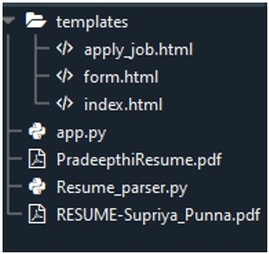
Create a folder and put the below files
- We are building a Flask Application which needs HTML pages stored in the templates folder and a python script App.py for serverside scripting
- A python file which is used for parsing the skills in the resume
- Two sample resumes for testing
Project files :
https://github.com/Guided-Projects/AI-Enabled-Candidate-Resume-Screening-Using-Sp acy-Entity-Recognition

Project Objectives
By the end of this project you will:
- Know the fundamental concepts of Named Entity Recognition
- Know how to use spacy trained model
- How to trigger an email using Python
- How to build basic web applications with flask

Milestone 1 : Screen the resume
In this section, you will learn how to screen the resume to extract skills from the resume.
Create a file named Resume_parser.py file in the folder that you created

Task 1: Import Libraries
Import the following libraries as shown in the figure below
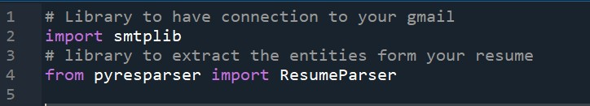
- smtp library is for connection to Gmail account
- pyresparser for extracting the skills from the resume

Task 2: Necessary Initializations
Initialize the following variables as shown in the below figure
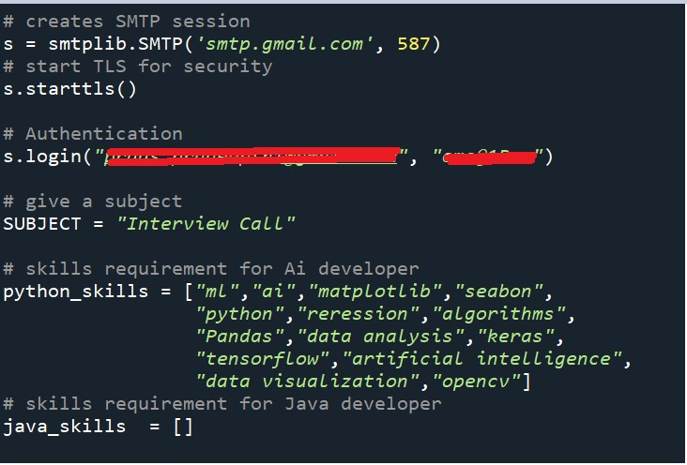
- Create an SMTP (Simple mail transfer protocol used to send and receive mails) session with the SMTP instance)
- The first parameter is the server location and the second parameter is the port to use. For Gmail, we use port number 587
- For security reasons, now put the SMTP connection in the TLS mode. TLS (Transport Layer Security) encrypts all the SMTP commands.
- Pass your Gmail account credentials in the login instance.
- Give the Subjet that you would like to put in the email
- Create a list which will have all the technical skills that are required for Ai developer
Note: You can create skills for any domain
smtp Reference : https://youtu.be/Y_tnWTjTfzY

Task 3: Extract the Parsed Skills
Now let's extract the information from a pdf by using the pyreparser package
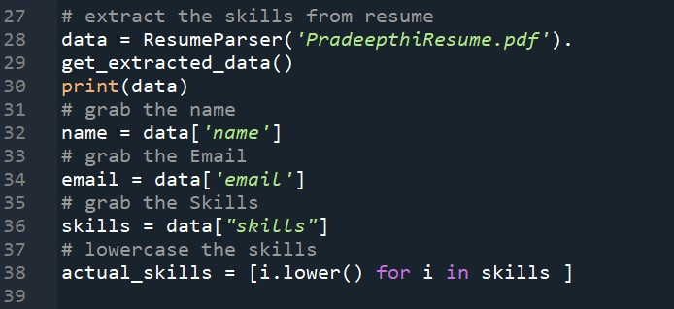
- By using inbuild class ResumeParser extract the entities recognized in the resume passed
- Grab the name of the candidate and place it in "name variable" , do the same for skills ad email
- Lower case all the skills grabbed

Task 4 :Compare The skills
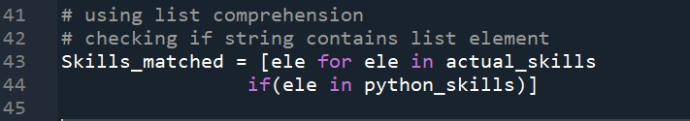
- Compare the skills grabbed from resume with the job required skils
- store the matched skills in a variable named "skills_matched

Task 5 : Trigger an email
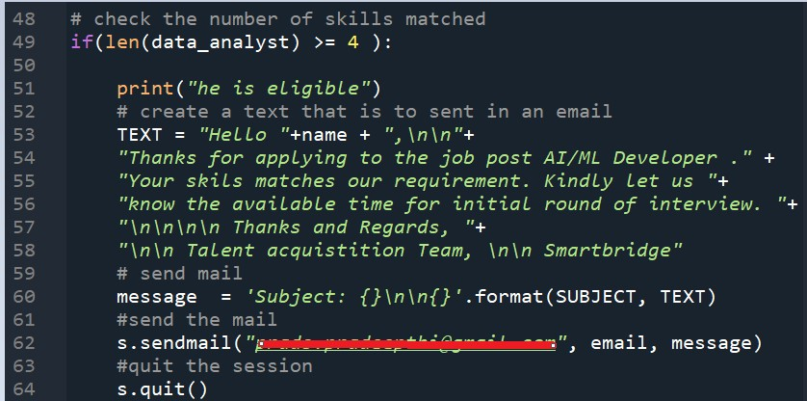
- Check the number of skills matched with the required skills. (replace data_analyst with Skills_matched) If the skills matched are greater than and equal to 4
- send an email to the applicant regarding his recruitment or
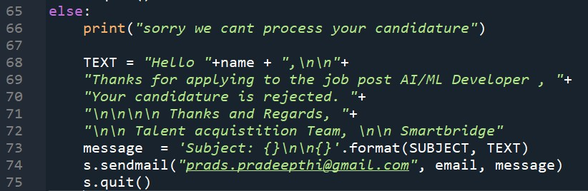

Milestone 2 : Building Flask Application
In this section, we will be building a web application. A UI is provided for the uses where he has to apply for a job and uploads his resume and get notified about his candidature
This section has the following tasks
- Building HTML Pages
- Building serverside script

Task 1 : Build HTML Pages
For this project create three HTML files namely
- home.html
- prediction.html
- projectdata.html save them in the templates folder download the HTML files from the given link in project structure section Let’s see how our home.html page looks like:
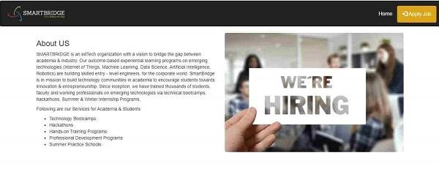

Apply Job Page
Now when you click on Apply job button from the top right corner you will get redirected to apply_job.html
Let's look at our apply_job.html.html file looks like:
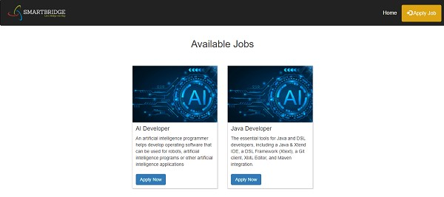
When ever you click on Apply Button you will get redirected to the application form .
from where you have to upload resume
and your form page looks like
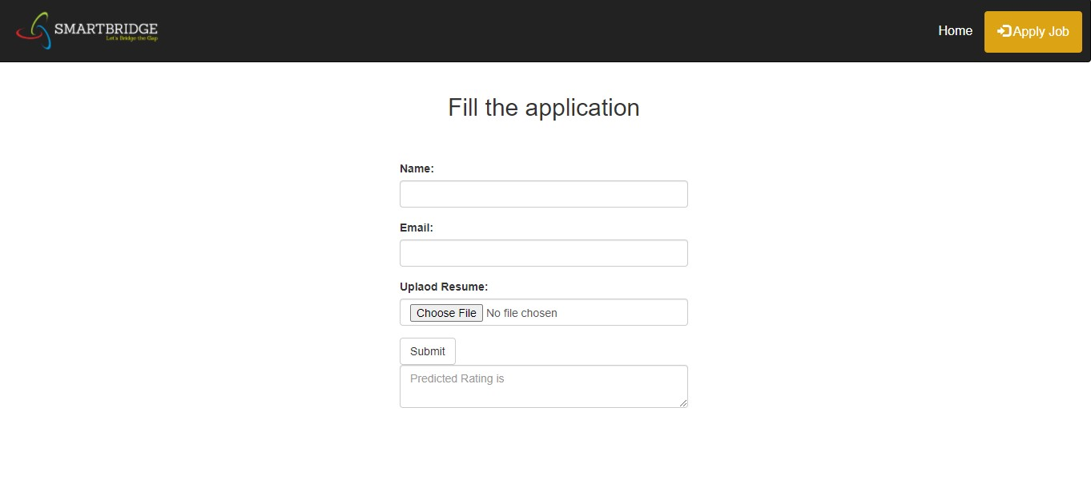

Task 2 : Build Python Code
Create a file name app.py in the folder created and follow the steps below
Import the libraries and initialization as we have done in the previous activity
Importing flask module in the project is mandatory. An object of Flask class is our WSGI application. Flask constructor takes the name of the current module (__name__) as argument
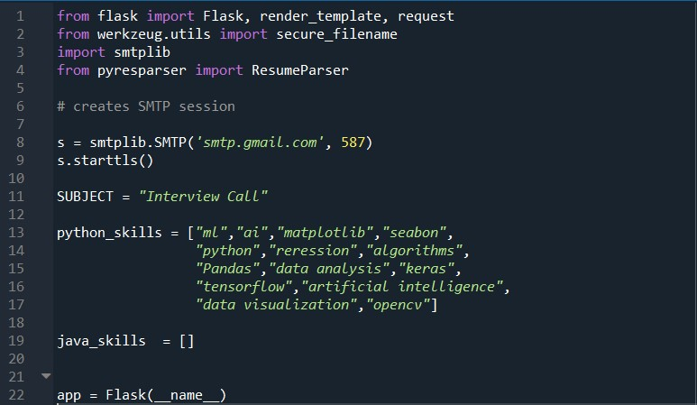
Render HTML Page:
Render the HTML pages by routing to the URLs given in the code
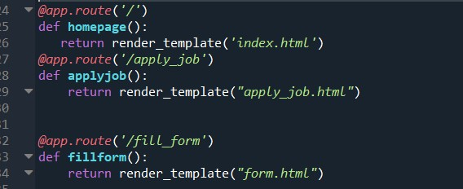
Here we will be using declared constructor to route to the HTML page which we have created earlier.
In the above example, ‘/’ URL is bound with respective HTML function. Hence, when the home page of the webserver is opened in the browser, the HTML pages will be rendered.
Task 3 : Build Python Code -2:
Resume parser:
Now this code implements resume parsing and generating an email alert
- we request the pdf file from the HTML page using a post request
- saving the file in the same folder
- passing the saved file for extracting data
- Then we generate an email based on the candidature
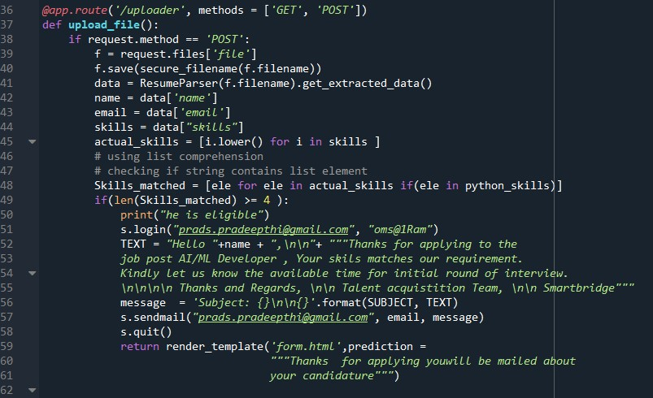
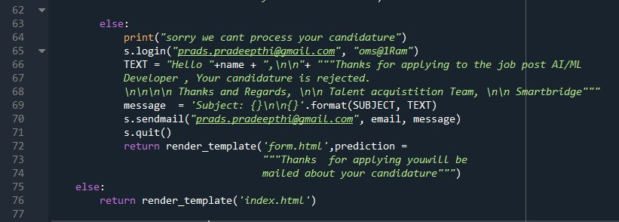
Task 4 : Run Flask App :
Run the Main Function
Create a main function and run the app
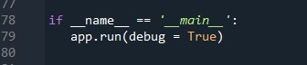
Open anaconda prompt from the start menu.
- Navigate to the folder where your app.py resides.
- Now type “python app.py” command.
- It will show the local host where your app is running (on http://127.0.0.1.5000/)
- Copy that localhost URL and open that URL in the browser. It does navigate you to view your web page.
- click on the predict button from the top right corner, enter the text, click on the predict button, and see the result/prediction on the web
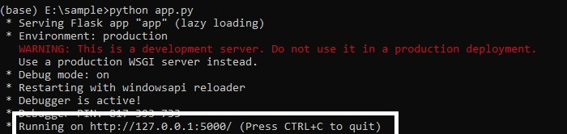
Your op looks like:

